THE UNIVERSITY OF AZAD JAMMU AND KASHMIR
Department of Software Engineering
Image processing technology lab 2

Student Name: Umair khan ikram
Roll Number: 2024_SET_27
Lab Instructor: Mam sidra
Semester: Fifth
Lab Task #01
Code
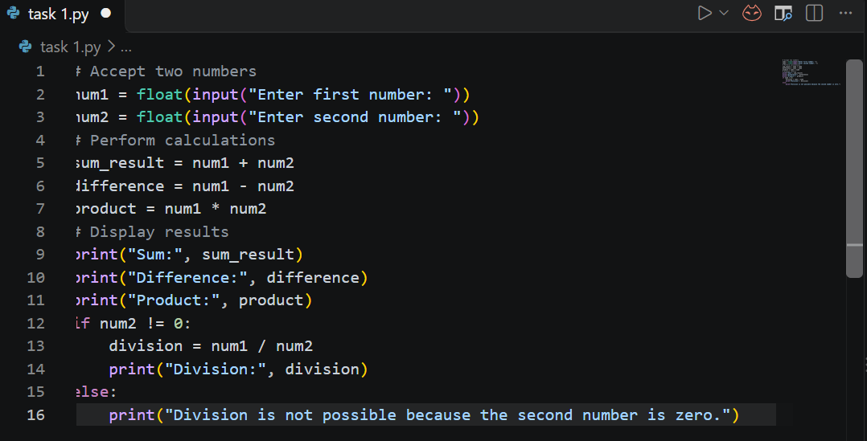
Output
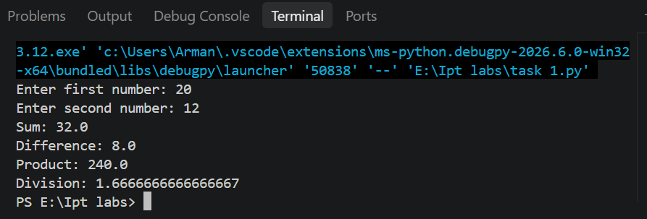
Lab Task #02
Code
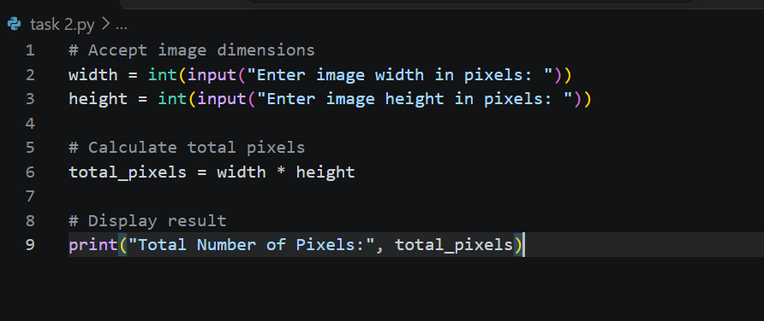
Output
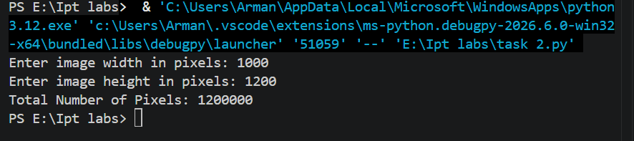
Lab Task #03
Code
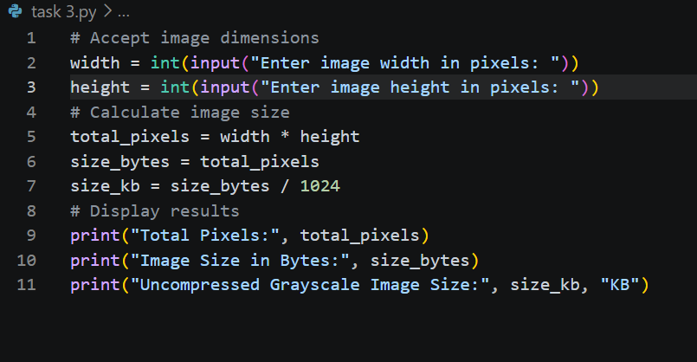
Output
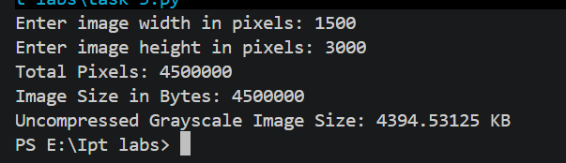
Lab Task #04
Code
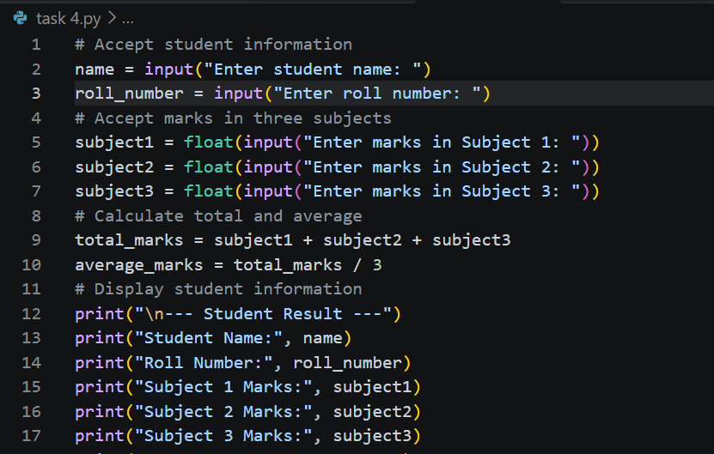
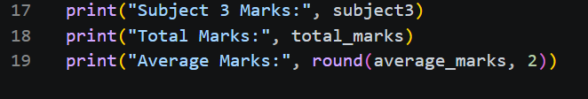
Output


